**HANDOUT 2**

**Machine Learning-Matplotlib and Pandas**

Q1. Write a Python program to draw a line using given axis values with suitable label in the x axis, y axis and a title.

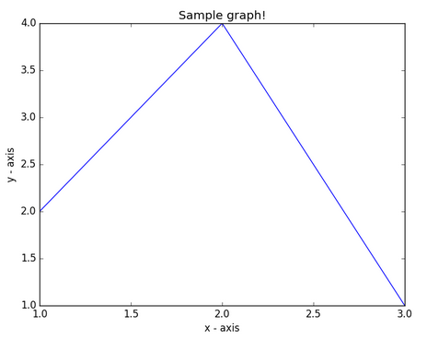

Solution: import matplotlib.pyplot as plt

# x axis values

x = [1,2,3]

# y axis values

y = [2,4,1]

# Plot lines and/or markers to the Axes.

plt.plot(x, y)

# Set the x axis label of the current axis.

plt.xlabel('x - axis')

# Set the y axis label of the current axis.

plt.ylabel('y - axis')

# Set a title

plt.title('Sample graph!')

# Display a figure.

plt.show()

( A line plot can be created by calling the [plot() function](https://matplotlib.org/api/_as_gen/matplotlib.pyplot.plot.html) and passing the x-axis data for the regular interval, and y-axis for the observations.)

Q2. Write a Python program to draw a line with suitable label in the x axis, y axis(3 times of x) and a title.

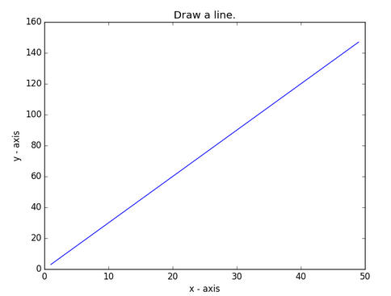

Solution:

import matplotlib.pyplot as plt

X = range(1, 50)

Y = [value * 3 for value in X]

print("Values of X:")

print(*range(1,50))

print("Values of Y (thrice of X):")

print(Y)

# Plot lines and/or markers to the Axes.

plt.plot(X, Y)

# Set the x axis label of the current axis.

plt.xlabel('x - axis')

# Set the y axis label of the current axis.

plt.ylabel('y - axis')

# Set a title

plt.title('Draw a line.')

# Display the figure.

plt.show()

Q3. Write a Python program to plot quantities which have an x and y position making use of *pylab*

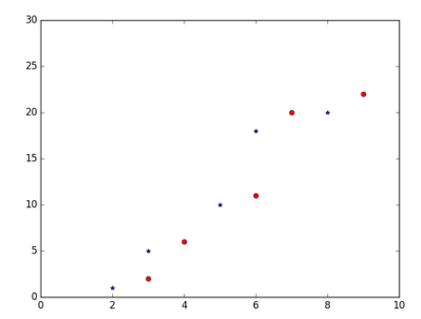

Solution:

import numpy as np

import pylab as pl

# Make an array of x values

x1 = [2, 3, 5, 6, 8]

# Make an array of y values for each x value

y1 = [1, 5, 10, 18, 20]

# Make an array of x values

x2 = [3, 4, 6, 7, 9]

# Make an array of y values for each x value

y2 = [2, 6, 11, 20, 22]

# set new axes limits

pl.axis([0, 10, 0, 30])

# use pylab to plot x and y as red circles

pl.plot(x1, y1,'b*', x2, y2, 'ro')

# show the plot on the screen

pl.show()

Q4. Write a Python program to plot several lines with different format styles in one command using arrays

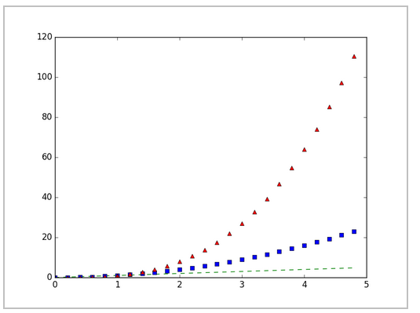

Solution: import numpy as np

import matplotlib.pyplot as plt

# Sampled time at 200ms intervals

t = np.arange(0., 5., 0.2)

# green dashes, blue squares and red triangles

plt.plot(t, t, 'g--', t, t**2, 'bs', t, t**3, 'r^')

plt.show()

Q5. Write a Python program to create multiple plots



Solution:

import matplotlib.pyplot as plt

fig = plt.figure()

fig.subplots_adjust(bottom=0.020, left=0.020, top = 0.400,right=0.500)

plt.subplot(2, 1, 1)

plt.xticks(()), plt.yticks(())

plt.subplot(2, 3, 4)

plt.xticks(())

plt.yticks(())

plt.subplot(2, 3, 5)

plt.xticks(())

plt.yticks(())

plt.subplot(2, 3, 6)

plt.xticks(())

plt.yticks(())

plt.show()

Q6. Write a Python program to display a DataFrame having values for Name, Exam, Subject and Result.

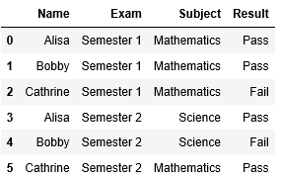

Solution: import pandas as pd

import numpy as np

d = { 'Name':['Alisa','Bobby','Cathrine','Alisa','Bobby','Cathrine'],

'Exam':['Semester 1','Semester 1','Semester 1', Semester2', 'Semester 2','Semester 2'], 'Subject':['Mathematics','Mathematics','Mathematics','Science','Science', 'Mathematics'],

'Result':['Pass','Pass','Fail','Pass','Fail','Pass']}

df = pd.DataFrame(d,columns=['Name','Exam','Subject','Result'])

df

Q7. Write a Python program to create a two-way cross tab for above DataFrame having for Subject vs Results summary.

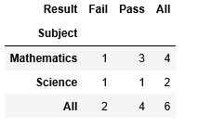

Solution: pd.crosstab(df.Subject, df.Result,margins=True)

Q8. Write a Python program to create a three-way cross tab for above DataFrame having for Subject,Exams vs Results summary.

Solution: 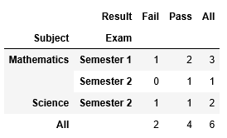

pd.crosstab([df.Subject, df.Exam],df.Result, margins=True)

Q9. Write a Python program to create a scatter plot having for given x and y values.

Solution:

import matplotlib.pyplot as plt

x = [5,7,8,7,2,17,2,9,4,11,12,9,6]

y = [99,86,87,88,111,86,103,87,94,78,77,85,86]

plt.scatter(x,y)

plt.show()

Q10 . Write a python program to read data from a csv file.(diabetes.csv)

Solution:

1. # Load libraries

import pandas as pd

# load dataset

pima = pd.read_csv('D://diabetes.csv')

X = list(pima.columns)

print("List of Attributes:", X)

X.remove('Outcome') #Remove the class attribute

print("Predicting Attributes:", X)

X=pima[X]

Y=pima.Outcome

pima.head()

1. import numpy as np

import pandas as pd

from pandas import DataFrame

df= pd.read_csv('D://weather.csv')

cols = list(df.columns)

print("List of Attributes:",cols)